

**Faculty of Engineering**

**Electronics and Electrical Communication Department**

**Image Correction For Color Blindness**

By: Electric Shots



Vivianne Emad

Mariam Mamdouh

Manar Kamal

Nardin Milad

Nour Ashraf

Yara Magdy

Yara Osama

Under the supervision of:

Dr. Samah El Shafiey

Abstract

Ever wondered what it's like to experience a world with fuller colors? Color blindness poses unique challenges in individuals' daily lives. In this project, our objective was to restore some of the lost colors for those with color vision deficiencies. To achieve this, we applied the You and Kaveh fourth-order differential and the LMS Daltonization Algorithm, creating a color enhancement filter. Our evaluation involved comparing unfiltered images with their filtered equivalents to assess the improvement in visual perception for colorblind individuals.

The images selected for the study are professional and commonly used in actual color blindness tests designed specifically for individuals with Deutan color blindness. These images are known to be particularly challenging for individuals with color vision deficiencies. After applying the color enhancement filter, there was a significant reduction in the total number of images not seen by participants, decreasing from 55 to 20. The average test score improved to approximately 13.5 out of 25. These results signify the effectiveness of our approach in enhancing color perception for individuals with Deutan color blindness.

Table of Contents

1. Introduction 4

**1.1.Motivation** 4

**1.2.Hypothesis** 5

2. Literature Review 5

**2.1. Optical Lenses For Color Enhancement** 5

**2.2. Deep Learning Color Correction** 6

**2.3. Saliency-Based Image Correction** 7

2.4. Simulation-Based color correction 7

**2.5. Enhancement Of Color Using Fourth Order Partial Differential** 8

3. Methodology 9

**3.1. You and Kaveh 4th order PDE** 9

**3.2. Conversion of RGB coordinates into LMS** 11

**3.2.1** **Removing gamma correction applied to RGB values** 12

**3.2.2** **Converting the linear RGB values to the XYZ color space using a transformation matrix** 12

**3.2.3** **Transforming the XYZ values to the LMS color space** 12

**3.3. Simulation of color blindness** 12

**3.4. Compensation for color blindness** 14

**3.5. Inverse transformation of LMS coordinates to RGB** 14

4. Experiment 16

**4.1. Data set** 16

**4.2. Results** 16

**4.3. Analysis** 18

5. Conclusion and future work 22

**5.1. Conclusion** 22

**5.2. Future work** 22

Works Cited 23

**Table of Figures**

**Figure 1: Effect of color adjusting glasses** 4

**Figure 2: Graph showing effect of Enchroma glasses** 6

**Figure 3: Deep Correct architecture. The top labels show actions taken in the forward pass, and the bottom labels show how errors are back propagated.** 7

**Figure 4: Enhancement process** 8

**Figure 5: Lena noisy Image (a) Original image (b) Enhanced from Mukherjee method (c) Enhanced from Murtaza method (d) Enhanced from Proposed method** 8

**Figure 6: Algorithm flowchart** 9

**Figure 7: The three types of cone length** [15] 11

**Figure 8: Examples of protan confusion line** [11] 13

**Figure 9: The effect of shifting wavelengths** [12] 14

**Figure 10 : some data set examples [13]** 16

**Figure 11: Pie chart for before and after ratios for all participants** 17

**Figure 12: Total not seen before and after** 17

**Figure 13 : test results** 18

**Figure 14: example for the not seen images [13]** 18

**Figure 15: response for Figure 14 before edition** 19

**Figure 16: response for Figure 14 after edition** 19

**Figure 17: pic1 after filter** 19

**Figure 18: pic1 before filter** 19

**Figure 19: pic1 results before applying filter** 20

**Figure 20 : pic1 results after applying filter** 20

**Figure 21: pic2 after filter** 21

**Figure 22: pic2 before filter** [13] 21

**Figure 23: results of pic2 before filter** 21

**Figure 24: results of pic2 after filter** 21

Table of Equations

**Equation 1: You and Kaveh fourth order Laplacian PDE** 8

**Equation 2** 9

**Equation 3** 9

**Equation 4: Euler’s equation** 10

**Equation 5** 10

**Equation 6: step image** 10

**Equation 7: facet image satisfies Euler’s equation** 11

**Equation 8: transformation matrix from RGB to XYZ** 12

**Equation 9: transformation matrix from XYZ to LMS** 12

**Equation 10: Projection plane equation** 13

**Equation 11: converting RGB to LMS** 15

**Equation 12: converting LMS back to RGB** 15

Table of Tables

**Table 1: Deutan answers** 16

**Table 2: Protan answers** 17

# 1. Introduction

Welcome to the exciting world of color vision enhancement!

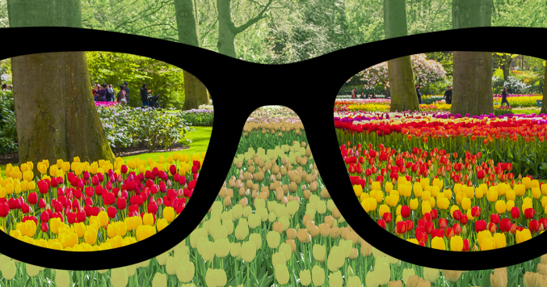In a world vibrant with colors, it's easy to take for granted the gift of seeing the world in all its vivid glory. However, millions of people with color blindness are unable to perceive the richness of color as others do, significantly impacting their daily lives.

Our project aims to provide a transformative solution that empowers individuals with color blindness to see and experience the world as it truly is. By combining the power of technology, science, and compassion, we aspire to make the world more colorful, more accessible, and more beautiful for all.

**F**

**Figure 1: Effect of color adjusting glasses**

We will explore the intricate technical aspects of color perception and the perceptual aspects of color blindness to develop an image enhancement filter that can compensate for the deficiencies in color vision, enabling color blind patients to distinguish colors more accurately and enhance their overall visual experience. We envision a future where everyone can experience the beauty of the world in its full spectrum of colors, regardless of their genetic makeup.

## **1.1.Motivation**

Color blindness, also known as color vision deficiency, is a condition that affects a significant portion of the global population. It poses unique challenges for individuals in their daily lives, particularly when it comes to perceiving and differentiating between various colors. The inability to accurately distinguish colors can hinder tasks that rely heavily on color identification, such as reading maps, interpreting traffic signals, and even selecting matching clothing or accessories. As electronics and electrical communication engineers, colorblind electrical engineers face difficulties in that profession, as it requires differentiating between colors of cables.

The impact of color blindness on individuals' lives is not limited to practical inconveniences; it can also have profound emotional and psychological consequences. Colorblind individuals may experience frustration, embarrassment, or a sense of exclusion due to their inability to perceive the world in the same way as those with normal color vision. These challenges can affect their self-esteem, limit career opportunities, and impede their overall quality of life.

Recognizing the significance of color blindness as a widespread issue, our research project aims to explore and develop a solution that can enhance the color perception capabilities of individuals with color vision deficiency. By leveraging mathematical principles and advanced technology, we intend to design smart glasses that have the potential to correct color blindness and provide an immersive and inclusive visual experience.

The primary goal of our project is to develop an image enhancement filter that can assist colorblind individuals in perceiving and distinguishing colors more accurately, thereby reducing the limitations they face in various aspects of their lives. Through the utilization of cutting-edge algorithms, image processing techniques, and artificial intelligence, our enhancement filter will analyze and adjust the incoming visual information, enabling users to perceive a broader spectrum of colors that were previously inaccessible to them.

By bridging the gap between mathematical concepts, technological advancements, and the needs of colorblind individuals, our project seeks to make a tangible difference in the lives of those affected by color blindness. Our aim is to create a practical, user-friendly solution that can empower individuals with color vision deficiency to navigate the colorful world with increased confidence and independence.

## **1.2.Hypothesis**

Currently, there is no cure for color blindness. However, there are some treatments that can help improve color vision, such as special glasses and contact lenses. These treatments can be expensive [1] and not always effective.

In addition to medical treatments, there are also a number of technological solutions that can be used to help people with color blindness. [2] One promising new area of research is the development of image correction methods for color blindness. These methods aim to modify images so that they can be more easily distinguished by people with color blindness by combining the existing methods with PDE for image enhancement. This could be done by adjusting the colors in the image, increasing the contrast between different colors, or highlighting important features in the image.

We believe that image correction methods have the potential to be a valuable tool for helping people with color blindness to experience the world around them more fully. Our project will contribute to the development of image correction methods that are effective and practical.

# 2. Literature Review

We studied the evolution of image enhancement and color correction technologies through the time and analyzed the different approaches taken do solve the problem. The correction methods ranged from optical solutions, analytical solutions and AI-based solutions.

## **2.1. Optical Lenses For Color Enhancement**

The main wearable devices used to aid color blind people is a form of tinted glasses. The idea of using colored filters came from Seebeck in 1837 [3]. By using a red filter followed by a green filter, Seebeck noted that patients could differentiate between the relative brightness of different shades of red and green. The red and green filters achieve the latter by blocking out wavelengths (540–580 nm), at which patients’ M-cone and L-cone overlap. After using the filters, both photoreceptor cells are activated individually depending on the wavelength of the incoming light. Moreover, the first pair of glasses, developed by Maxwell in 1857, was made of one lens dyed green and the other red. CVD subjects were able to discriminate between previously indistinguishable colors. From these results, Maxwell hypothesized that after prolonged exposure to the glasses, subjects were able to differentiate between more shades of red and green out of habit [4].

Right now, the most famous optical lenses company is Enchroma [5]. Enchroma is an American company that produces lens technology that helps people with color vision deficiency. They received a SBIR grant from the National Institutes of Health (NIH) and earned the 2016 Tibbets Award from the U.S. Small Business Administration in recognition of their work.

Enchroma offers suitable eyewear for both outdoor and indoor use for people of all ages. The Enchroma glasses work by filtering light to increase the contrast between the red and green signals which enhances the sight of those with color blindness. That happens through an optical technology that filters out the wavelengths of light that overlap together giving a better color discrimination for the person wearing the glasses. Approximately 80% of the people with red-green color blindness see better with Enchroma glasses.

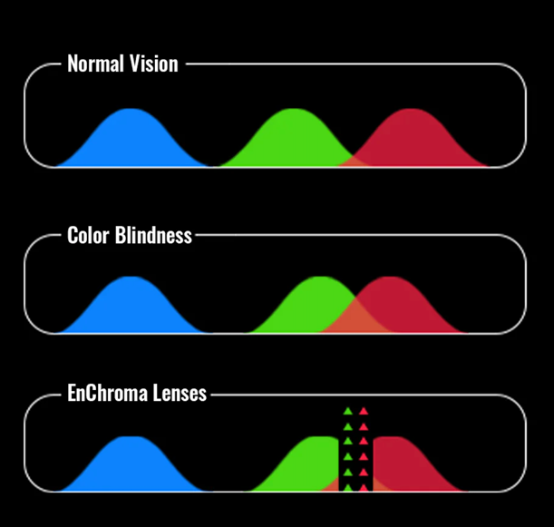

**Figure 2: Graph showing effect of Enchroma glasses**

## **2.2. Deep Learning Color Correction**

Deep Correct [6]. is a novel Deep Learning based method for color correcting images in order to improve accessibility for people with color vision deficiency.

This system works by using two modules, a corrector neural network and a referee neural network. The correct performs color correction on the image and the referee evaluates the result then through backpropagation the corrector trains again. The main goal of the corrector is to compensate for any information loss in the colors which means it doesn’t only apply color enhancement for people with color blindness but improves the overall quality of the images by noise reduction. The proposed model performed comparably well compared to the base line but it did introduce some noise and some colors appeared unnatural.

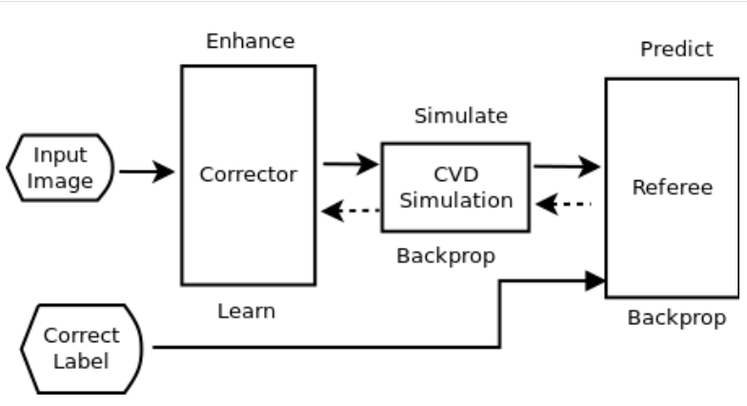

**Figure 3: Deep Correct architecture. The top labels show actions taken in the forward pass, and the bottom labels show how errors are back propagated.**

## **2.3. Saliency-Based Image Correction**

Saliency-based image correction [7] for colorblind patients is a technique that aims to enhance the visibility and contrast of colors in images for people who have difficulty distinguishing certain colors. The method uses a saliency map, which is a representation of the most important and noticeable regions in an image, to guide the color correction process. The saliency map is computed based on the color difference between the original image and a simulated image that mimics the color perception of a colorblind person. The color correction algorithm then adjusts the shade, saturation and brightness of the pixels in the salient regions to make them more distinguishable for the colorblind viewer. The result is an image that preserves the natural appearance of the scene, while improving the color discrimination for the colorblind patients.

The paper evaluates the proposed method on various images and compares it with other methods. The paper shows that the proposed method can effectively improve the saliency contrast and perception of colorblind images, and make the salient regions more consistent with those of normal images.

# 2.4. Simulation-Based color correction

The LMS Daltonization [8] algorithm, also known as the LMS Cone Contrast Space Daltonization algorithm, is a color transformation method used to enhance color vision for individuals with color blindness. It is named after the L, M, and S cones, which are the three types of photoreceptor cones responsible for detecting different ranges of wavelengths in the human visual system.

The algorithm works by transforming the colors in an image from the standard RGB color space to a modified color space based on cone contrast in order to simulate how the person with color deficiency sees the world. The goal is to increase the distinguishability of colors for individuals with color vision deficiencies, particularly red-green color blindness (protanopia and deuteranopia).

This method aims to shift the colors along the confusion lines experienced by individuals with red-green color blindness toward colors that are more distinguishable. By doing so, it helps individuals with color vision deficiencies better perceive and differentiate between certain colors.

## **2.5. Enhancement Of Color Using Fourth Order Partial Differential**

This method [9] doesn’t enhance the colors for color blind people but instead focuses on using PDE for color enhancement in general. The method utilizes a four-stage process, involving a fourth-order PDE, to enhance color medical images. This approach transforms the pixel values of an image to create a visually appealing result that is well-suited for analysis, as depicted in the provided block diagram.

**Figure 4: Enhancement process**

The PDE used is the PDE proposed by You and Kaveh [10] which is given as:

**Equation 1: You and Kaveh fourth order Laplacian PDE**

To enhance color images, they need to be transformed from the RGB color space to other specified spaces, and then the inverse coordinate transformation is applied for image display. S type enhancement is applied to enhance the contrast in the grayscale image and the same operation is applied on the RGB space to preserve the original hue.

The picture shows the comparing between the enhanced image and original image. After comparison, it is show that the detail information of enhance image is more accurate and resolving power is increased in the modified image. The results show that the proposed method can serve as a base for further analyzing and diagnosing purpose and is a very effective and important preparation step. 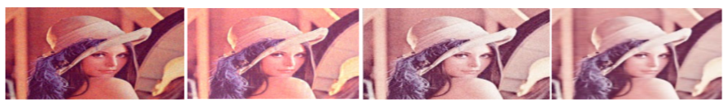

**Figure 5: Lena noisy Image (a) Original image (b) Enhanced from Mukherjee method (c) Enhanced from Murtaza method (d) Enhanced from Proposed method**

**3. Methodology**

For this project, out of all methods mentioned before, Fourth Order Partial Differential is used for color enhancement. Then LMS Daltonization [8] is used to increase the distinguishability of colors for individuals with color vision deficiencies, particularly red-green color blindness

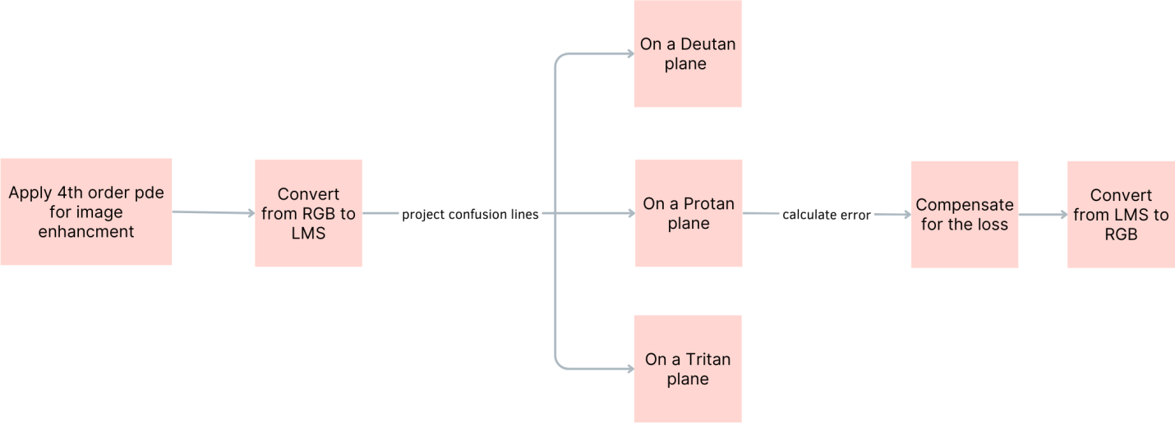

**Figure 6: Algorithm flowchart**

**3.1. You and Kaveh 4th order PDE**

Introducing a class of fourth-order partial differential equations (PDEs), You and Kaveh method [10] optimizes the balance between noise removal and edge preservation. The PDEs minimize a functional dependent on the Laplacian of image intensity, generating smoother images over time. Stationary points of these PDEs result in images combining plane images of various boundaries, yielding a more natural appearance than anisotropic diffusion. Despite potential speckle artifacts, characterized as isolated white and/or black dots, simple denoising algorithms effectively alleviate these issues.

Grey scale images are exclusively considered in the context of this study, with the scalar-valued function u representing observed images. The function takes on quantized integer values ranging from 0 to 255 and is a composition of a "true" image v combined with noise n. The objective of image denoising is to recover the true image v from the observed image u—an inherently challenging task due to the potential ambiguity between fine details of an image and noise. Denoising methods commonly introduce blurring, staircasing, and other artifacts.

Let us first consider the following functional defined in the space of continuous images over a support of :

**Equation 2**

Where denotes the Laplacian operator. We require that the function and is an increasing function:

**Equation 3**

So that the functional is an increasing function with respect to the smoothness of the image as measured by. Therefore, the minimization of the functional is equivalent to smoothing the image. The minimum of the functional may be found by solving the following Euler's equation:

=0 for all (

**Equation 4: Euler’s equation**

Where we define = 0

Which can be represented as

=0 for all (

**Equation 5**

Let us refer to an image whose intensity function satisfies a plane equation as a plane image. For such an image, its Laplacian is zero, so it satisfies the Euler's equation **Equation 5**. Therefore, a plane image is obviously a global minimum of the functional **Equation 2**.

Let be a partition of . We define a facet image as

A step image is the sum of a finite number of dislocated two-dimentional step functions.

**Equation 6: step image**

We require that the plane images in (10) be such that the combined image s(z, y) is continuous. Note that any two adjacent and must be on different planes; otherwise, we can combine them as one. Let us denote as the boundary of partion, then - is the interior of . It is obvious that

-

So we have

-

For

Therefore,

, -

Where . Since it is required that any two adjacent and be on different planes, we have

For any two adjacent partions and . This indicates that the gradient is not continuous at the boundary . So we have

, for all (

If we required that

We then have

for all (,

There, a facet image satisfies the Euler’s equation.

**Equation 7: facet image satisfies Euler’s equation**

**3.2. Conversion of RGB coordinates into LMS**

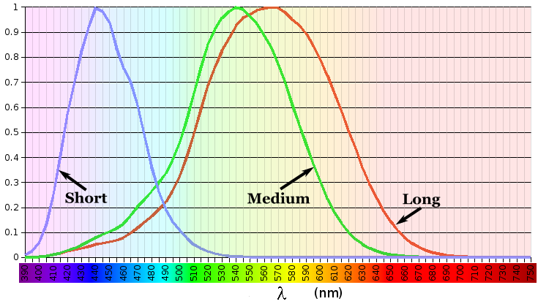Human trichromats have three types of cone cells, each sensitive to different wavelengths of light. Cone cells are stimulated by different wavelengths, and our visual system perceives color by comparing the relative stimulations of these cones. Each type of color deficiency is missing one or more cones. For example, Protanopia is missing L cone, deuteranopia is missing M cone, Tritanopia is missing S cone and monochromacy is missing either M and L cones or all cone types.

**Figure 7: The three types of cone length** [15]

To facilitate color blindness simulation, the RGB (Red, Green, Blue) color space is converted to the LMS (Long, Medium, Short) color space. LMS color space is a perceptually uniform color space that attempts to model the way the human eye perceives colors. The conversion involves several steps including:

* + 1. **Removing gamma correction applied to RGB values**

To ensure that the resulting LMS color space representation corresponds more accurately to the way humans perceive colors.

* + 1. **Converting the linear RGB values to the XYZ color space using a transformation matrix**

XYZ color space is a standard color space that is designed to be a linear transformation of RGB. The transformation from RGB to XYZ is achieved using a 3x3 matrix:

**Equation 8: transformation matrix from RGB to XYZ**

The scaling factors , , and depend on the RGB color space and are used to linearize the RGB values.

* + 1. **Transforming the XYZ values to the LMS color space**

The conversion from XYZ to LMS involves another 3x3 matrix:

**Equation 9: transformation matrix from XYZ to LMS**

The scaling factors , , and are chosen based on the specific properties of the LMS color space.

**3.3. Simulation of color blindness**

In the LMS color space, people with color blindness cannot differentiate between colors that differ by the coordinate of the axis missing. These colors form what’s known as confusion lines.

For example, a protanope cannot tell apart colors that only differ by the L component. This further highlights the importance of converting from RGB space to LMS, as such connections do not appear in the RGB space.

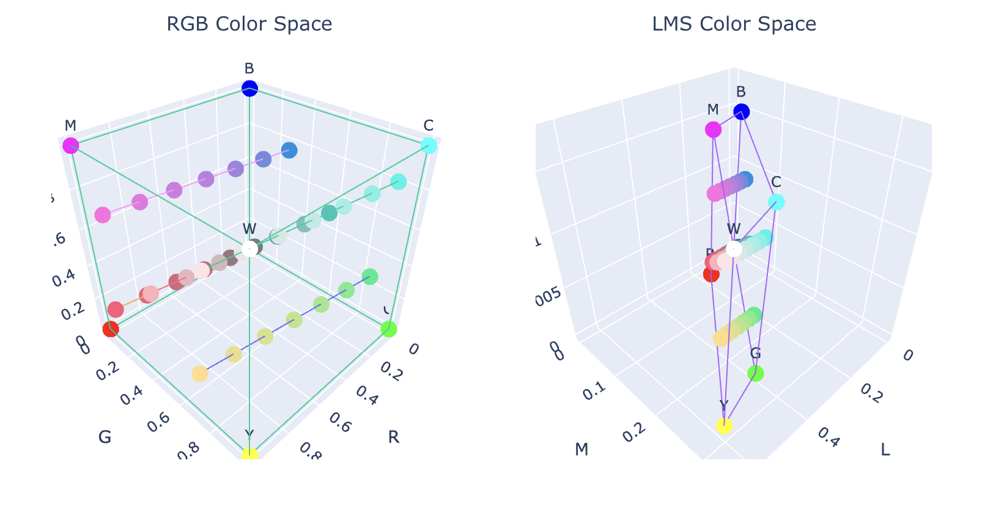

**Figure 8: Examples of protan confusion line** [11]

Constructing the confusion lines is essential for simulating colorblindness because they gather all the missing information, so after the converting to LMS coordinates the next step is choosing one color to map each line to since this behavior best mirrors what an actual color-blind person see.

There are multiple ways of doing so, one Idea is by creating a plane that contains all the colors visible to each type of colorblindness and project the colors of the confusion lines onto that plane.

The components of the cones that are fully perceived by the color-blind person are preserved while the last cone is projected as a function of the other two cones.

If the color we wish to convert is p = (pl​,pm​,ps​), n = (nl, nm, ns) is the normal to the plane, and the planes go through the origin (0,0,0) which is the color black. Then, the new projected p′=(pl′​,pm′​,ps′​) can be obtained through the equation:

**Equation 10: Projection plane equation**

**3.4. Compensation for color blindness**

The compensation technique involves modifying the colors in an image by shifting the wavelengths away from the problematic region of the spectrum towards a portion that remains visible to the dichromat. This shift aims to create color differences that are more discernible and enhance the overall color perception for colorblind individuals.

To compensate this defect a specially designed filter can be used. The requirement for this filter is to shift the Middle wavelength intensity of the light reaching the eye in such a way, that the color vision deficient receptors sensing the shifted spectrum send the same information to the visual nervous system, as the normal receptors would do sensing the unaltered incoming light. The filter has to be effective in the middle wavelength area where the deficiency is, and cause the least possible interference in the Short and Long wavelength range where the receptors of the color vision deficient subject are normal. As a result, the visual information becomes much closer to normal color vision than it was before.

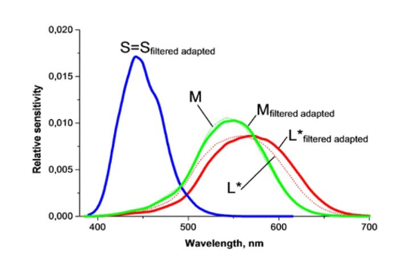

**Figure 9: The effect of shifting wavelengths** [12]

The specific approach for shifting wavelengths can vary, but it generally involves transforming the colors in a way that preserves the relative relationships and maintains the overall appearance of the image while making colors more distinguishable.

**3.5. Inverse transformation of LMS coordinates to RGB**

To convert RGB values to LMS, typically a conversion matrix is used. The conversion matrix relates the RGB values to the LMS values. Let's denote this matrix as M.

To convert an RGB color [R, G, B] to LMS, we would perform the matrix multiplication as follows:

**Equation 11: converting RGB to LMS**

Here, [R], [G], and [B] are the normalized RGB values (usually ranging from 0 to 1), and [L], [M], and [S] represent the resulting LMS values. where T is the transformation matrix.

To convert LMS values [L', M', S'] back to RGB, you need the inverse matrix of T, denoted as The inverse matrix allows you to go from LMS to RGB.

The equation to convert LMS to RGB is :

**Equation 12: converting LMS back to RGB**

Here, [R], [G], and [B] will be the resulting RGB values.

To perform this conversion, we'll need to know the specific values in the conversion matrix T and its inverse . These values depend on the specific color space or color model being used. The conversion matrices can be determined through mathematical modeling or experimental measurements.

**4. Experiment**

We have created a Google Form that includes approximately 22 testing images specifically designed for individuals with Deutan color blindness, also known as deuteranomaly. Deutan color blindness is the most common type of red-green color blindness, characterized by an imbalance in the detection of red and green light by the green cones in the eye. The purpose of these images is to simulate how individuals with Deutan color blindness perceive colors

**4.1. Data set**

In order to obtain accurate results, we have carefully selected professional images that are commonly used in real color blindness tests. These images are known to confuse individuals with color blindness and help assess the severity of their condition. By using such images, we aim to gather precise data regarding the color perception of individuals with Deutan color blindness.

Here are some examples for the dataset

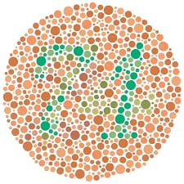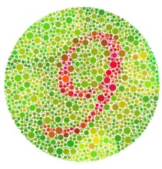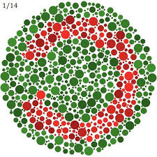

**Figure 10 : some data set examples [13]**

**4.2. Results**

In this study, we aimed to investigate the effectiveness of the filter designed to assist individuals with color blindness or color vision deficiency. The filter was developed and tested on a sample of participants who were members of a Facebook group called "Color Blindness/Color Vision Deficiency," which consisted of approximately 6.5k members, Where 8 filled our form and they have deutan color blindness and 1 filled another form and he has protean color blindness.

We recorded the answers for each of the 11 pictures we used

|  |  |  |  |  |  |  |  |  |  |  |  |
| --- | --- | --- | --- | --- | --- | --- | --- | --- | --- | --- | --- |
| Entry | Mirror c | Rainbow | 74 | 12 | 15 | C | Snake | 10 | 8 | 9 | Rainbow 2 |
| Before | After | | | | | | | | | | |
| 1 | ✓|🗶 | ✓|✓ | 🗶|✓ | ✓|✓ | 🗶|✓ | 🗶|🗶 | ✓|✓ | ✓|✓ | 🗶|✓ | ✓|✓ | ✓|✓ |
| 2 | 🗶|✓ | 🗶|🗶 | 🗶|✓ | ✓|✓ | 🗶|✓ | ✓|🗶 | 🗶|✓ | ✓|✓ | 🗶|✓ | ✓|✓ | 🗶|🗶 |
| 3 | 🗶|✓ | 🗶|✓ | 🗶|✓ | ✓|✓ | 🗶|✓ | 🗶|🗶 | 🗶|✓ | 🗶|✓ | 🗶|✓ | ✓|✓ | 🗶|🗶 |
| 4 | ✓|✓ | ✓|✓ | 🗶|✓ | ✓|✓ | 🗶|✓ | ✓|🗶 | 🗶|✓ | ✓|✓ | 🗶|✓ | ✓|✓ | 🗶|🗶 |
| 5 | 🗶|✓ | 🗶|🗶 | 🗶|✓ | ✓|✓ | 🗶|✓ | ✓|🗶 | 🗶|✓ | 🗶|✓ | 🗶|✓ | ✓|✓ | 🗶|🗶 |
| 6 | 🗶|✓ | 🗶|✓ | 🗶|✓ | ✓|✓ | 🗶|✓ | 🗶|🗶 | 🗶|✓ | 🗶|✓ | 🗶|✓ | ✓|✓ | ✓|🗶 |
| 7 | 🗶|✓ | 🗶|🗶 | 🗶|✓ | ✓|✓ | 🗶|✓ | 🗶|🗶 | 🗶|✓ | 🗶|✓ | 🗶|✓ | 🗶|✓ | 🗶|🗶 |
| 8 | ✓|✓ | 🗶|🗶 | 🗶|✓ | ✓|✓ | 🗶|✓ | ✓|🗶 | 🗶|✓ | ✓|✓ | 🗶|✓ | ✓|✓ | 🗶|🗶 |

**Table 1: Deutan answers**

|  |  |  |  |  |  |  |  |  |  |  |  |
| --- | --- | --- | --- | --- | --- | --- | --- | --- | --- | --- | --- |
| Entry | Mirror c | Rainbow | 74 | 12 | 15 | C | Snake | 10 | 8 | 9 | Rainbow 2 |
| Before | After | | | | | | | | | | |
| 1 | 🗶|✓ | 🗶|🗶 | 🗶|✓ | ✓|✓ | 🗶|✓ | ✓|✓ | ✓|✓ | ✓|✓ | 🗶|✓ | ✓|✓ | 🗶|🗶 |

**Table 2: Protan answers**

We measured the effectiveness of our filter based on the increment of the numbers of pictures seen for each response.

For each participant we calculated , the threshold was 1, which means the filter had no effect, a ratio higher than one indicates that the filter had a negative effect, and the ratios less than one indicate higher effectiveness.

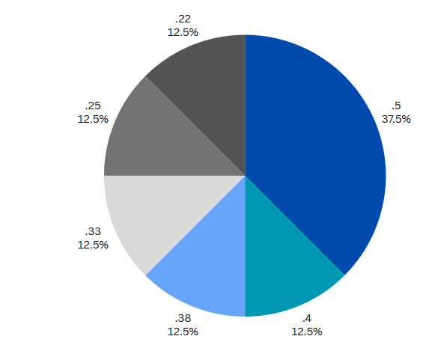We can see that the total number of pictures not seen for all participants drops greatly after applying the filter.

**Figure 11: Pie chart for before and after ratios for all participants**

We can see that the total number of pictures not seen for all participants drops greatly after applying the filter.

**Figure 12: Total not seen before and after**

**4.3. Analysis**

the average of the test was about 13.5/25 and the median 12/25 and the range was about 10-18 points

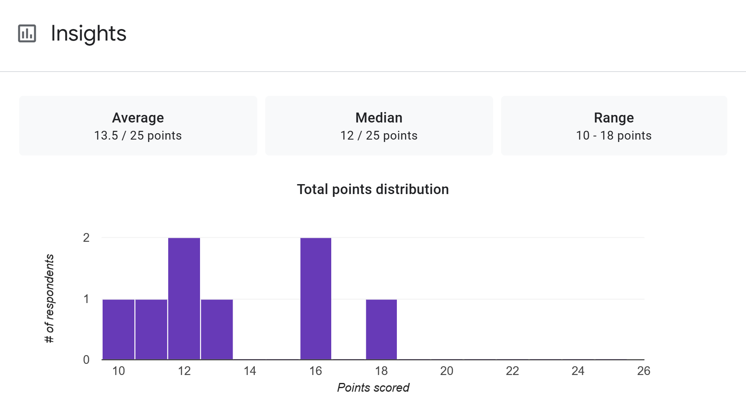

**Figure 13 : test results**

We have noticed that the defection appears clearly when the color of the number or the symbol is somehow matched with the background colors (from the same ballet) which causes confusion to determine it on the other hand when there is a noticeable contrast between their shades or colors it is easy to catch It as the following samples.

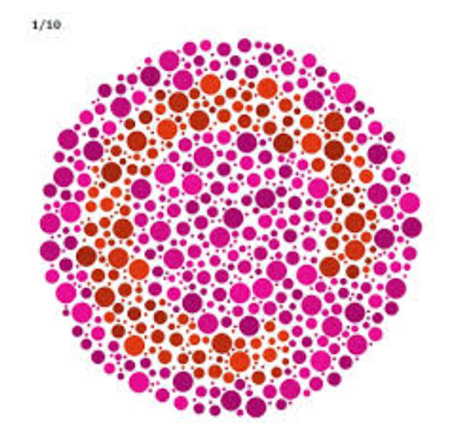

**Figure 14: example for the not seen images [13]**

Here are the responses for **Figure 14** before edition

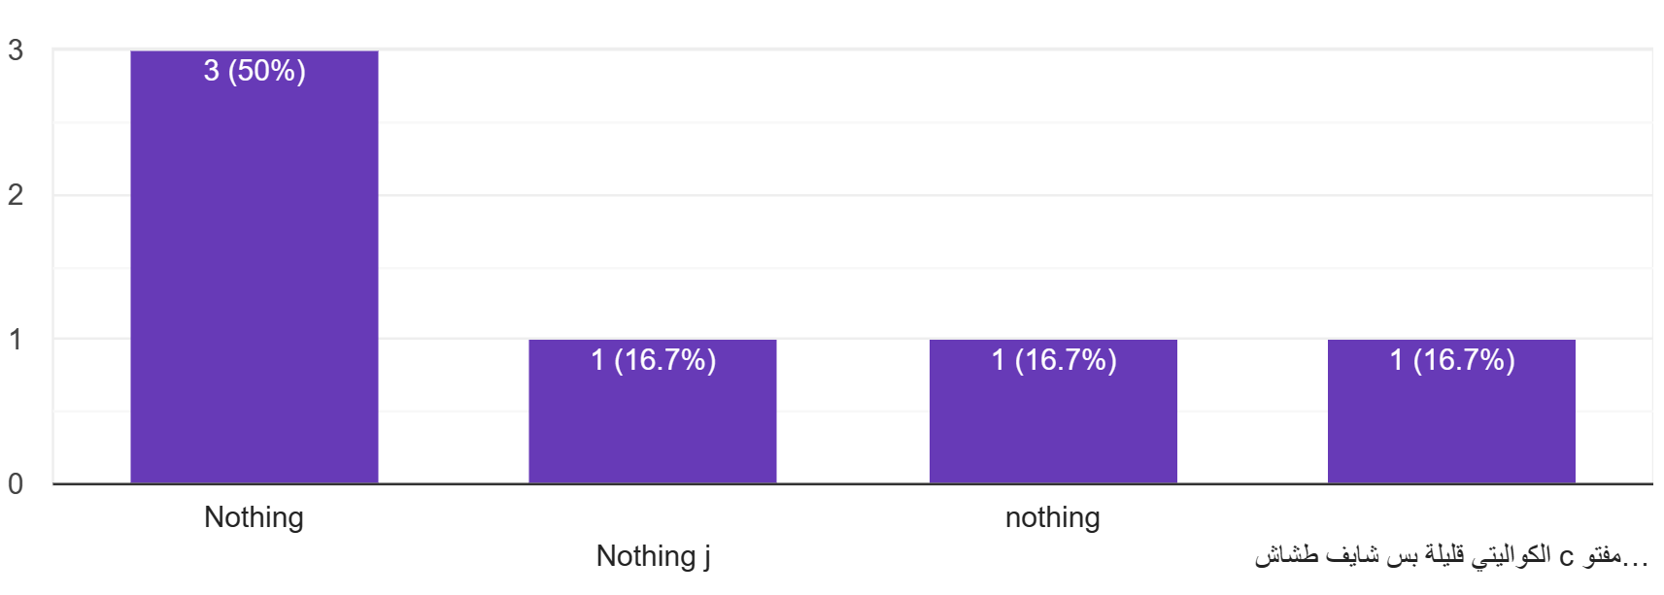

**Figure 15: response for Figure 14 before edition**

Here are the responses for **Figure 14** after edition

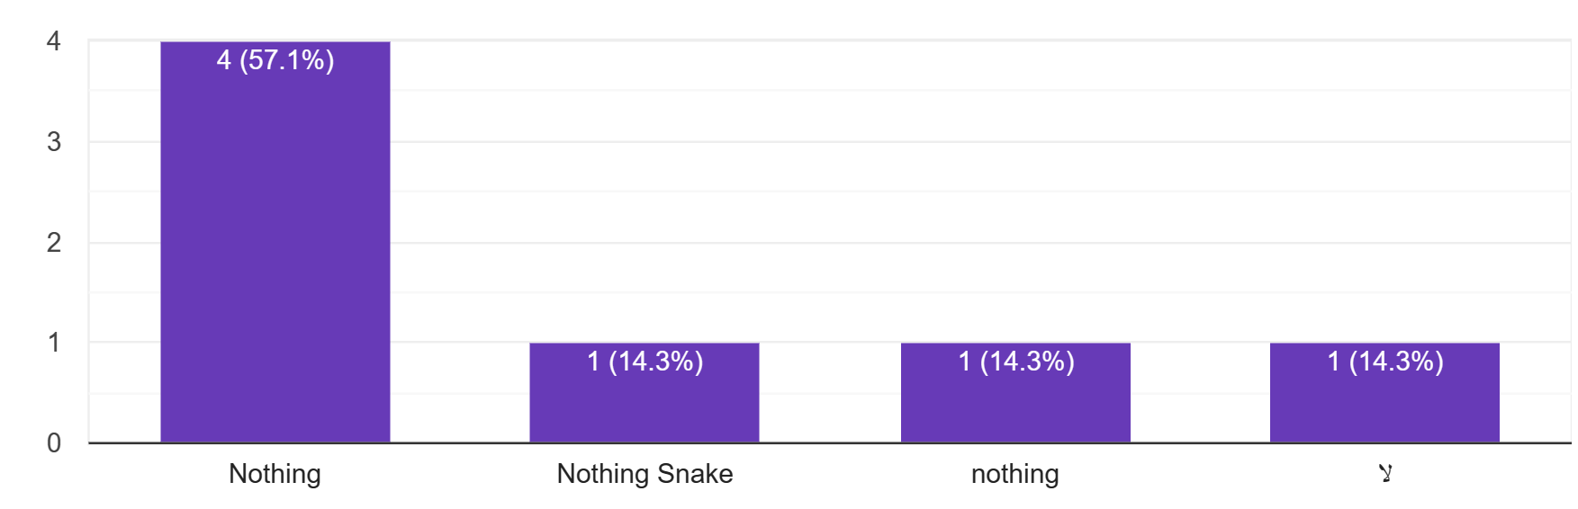

**Figure 16: response for Figure 14 after edition**

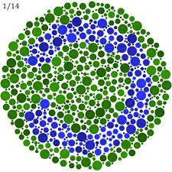Here are some of the results which are enhanced after applying the filter 

**Figure 17: pic1 after filter**

**Figure 18: pic1 before filter**

Most of the answers were that the user cannot see the image properly , here are the results

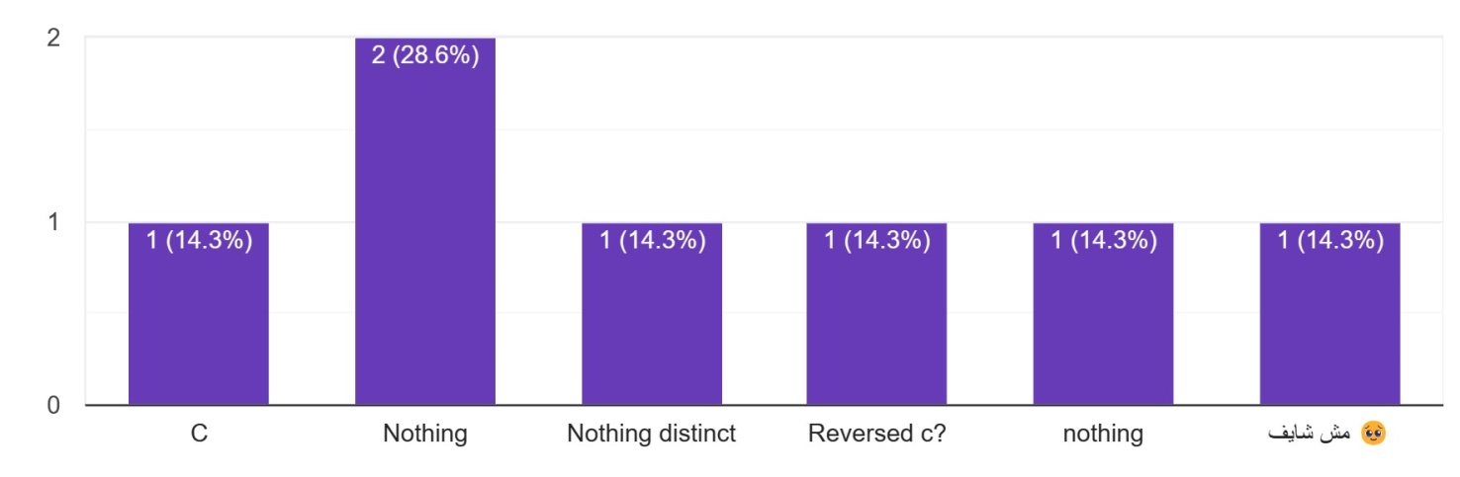

**Figure 19: pic1 results before applying filter**

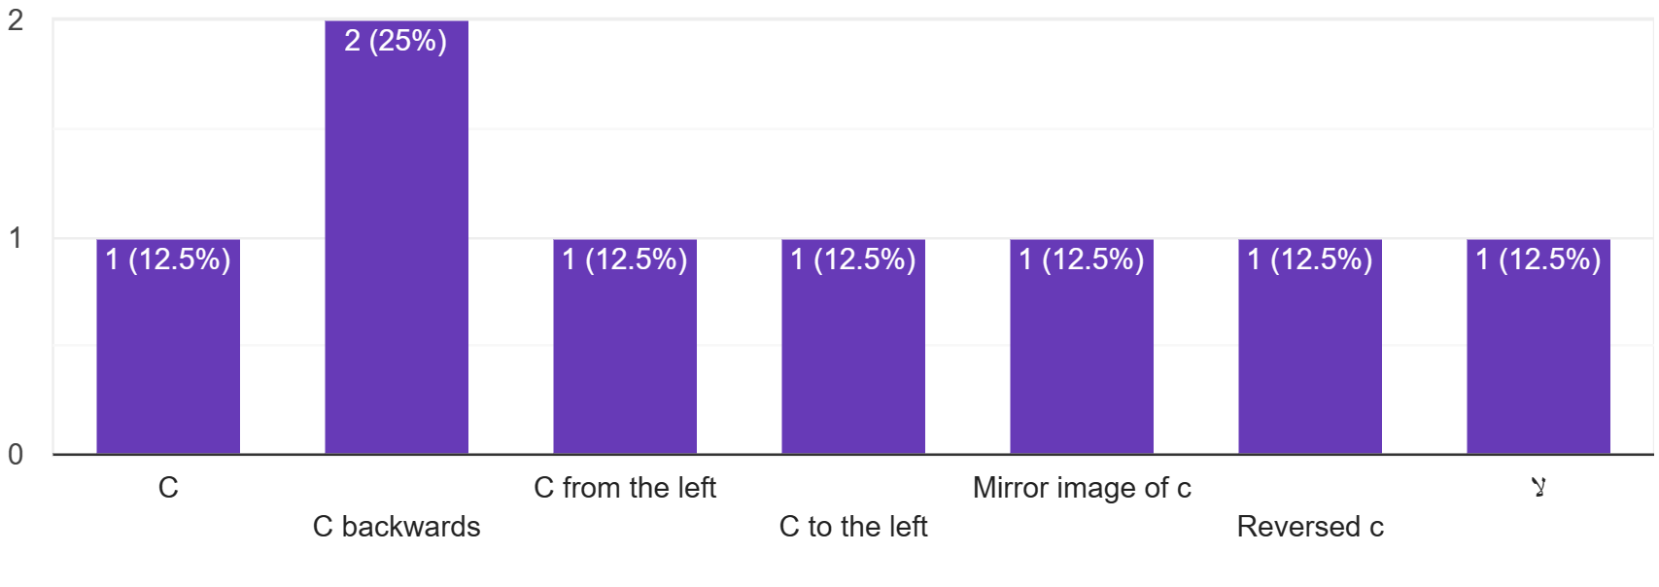

**Figure 20 : pic1 results after applying filter**

As we see most of the responses were right after applying the filter which shows that the filter made the image clearer for the color blinded

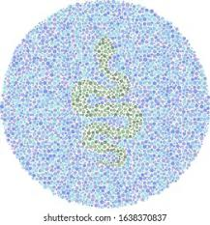Another example,

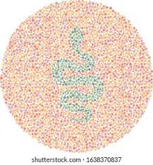

**Figure 21: pic2 after filter**

**Figure 22: pic2 before filter** [13]

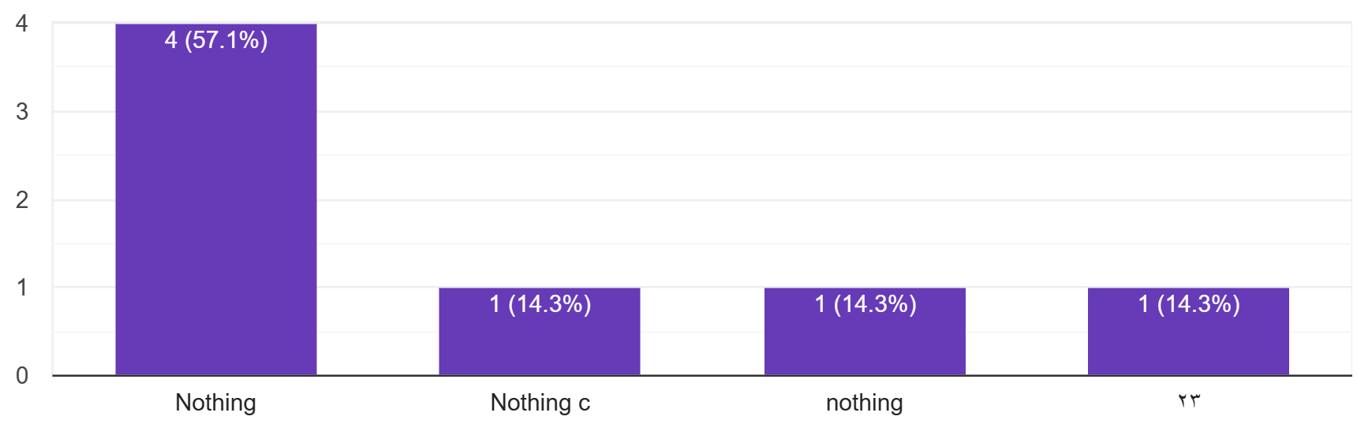

**Figure 23: results of pic2 before filter**

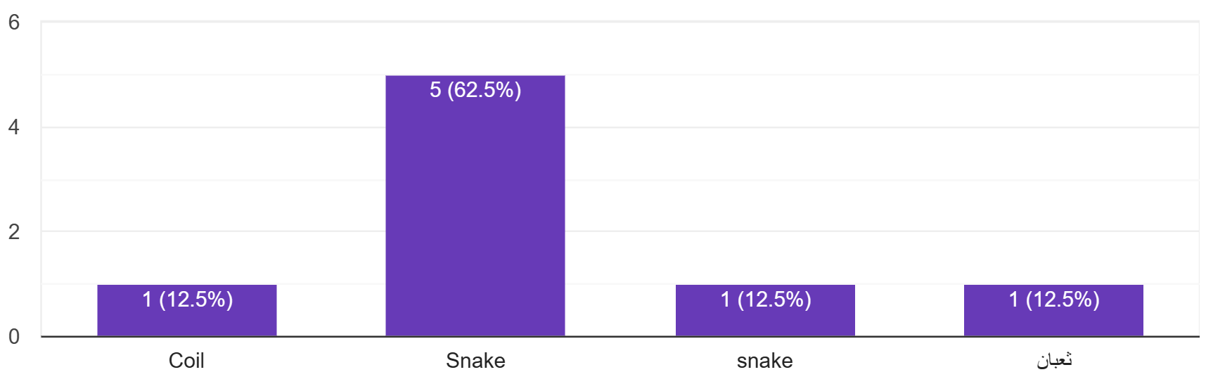

**Figure 24: results of pic2 after filter**

As we see the results shows that most of users had seen the image quite well after applying the filter.

# 5. Conclusion and future work

## **5.1. Conclusion**

In summary, our project aimed to help people with color blindness by using different technologies and methods. We were inspired by the practical and emotional challenges faced by those with color vision problems. We explored solutions like special glasses and advanced ways to fix images. Our main method involved using fourth-order partial differential equations and LMS Daltonization.

Through experimentation with individuals with Deutan and Protan color blindness, our filter demonstrated a significant improvement in color perception. The analysis revealed a notable decrease in the number of pictures not seen after applying the filter, showcasing its effectiveness. This project contributes to the ongoing efforts to make the world more accessible for individuals with color vision deficiency, with the goal of creating a tangible impact on their lives. As we move forward, the focus remains on refining and expanding our solution to enhance color perception and foster inclusivity in the visual experience.

## **5.2. Future work**

We have completed the design of our model, and it is currently available for use. However, we have not yet had the opportunity to convert our project into a portable software due to time constraints.

* Our next goal is to develop a user-friendly application that can be easily utilized by patients of all ages in real time.
* Once we achieve this, we will convert this software into a hardware specified glass based on our model
* The final step in our plan is to enhance our model using the latest AI techniques. These techniques may include deep learning, neural networks, and advanced statistical analysis.

Our goal is to ensure that our model stays up-to-date with the rapidly evolving field of AI.

# Works Cited

|  |  |
| --- | --- |
| [1] | E. Swain, "Color Blind Glasses," 25 10 2023. [Online]. Available: https://www.visioncenter.org/eyeglasses/color-blind-glasses/. [Accessed 27 10 2023]. |
| [2] | "Color Blindness," 17 3 2023. [Online]. Available: https://my.clevelandclinic.org/health/diseases/11604-color-blindness. |
| [3] | L. T. Sharpe and H. Jägle, "I used to be color blind," *Color Research & Application,* vol. 26, 2001. |
| [4] | P. Lanthony, The history of color blindness, Wayenborgh Publishing, 2018. |
| [5] | Enchroma, "EnChroma® Color Blind Glasses | Color Blind Eyewear," Enchroma, [Online]. Available: https://enchroma.com/. [Accessed 1 11 2023]. |
| [6] | G. Petrovic and H. Fujita, "Deep Correct: Deep Learning Color Correction for Color Blindness.," in *SoMeT*, 2017. |
| [7] | J. Li, X. Feng and H. Fan, "Saliency-based image correction for colorblind patients," *Computational Visual Media,* vol. 6, pp. 169-189, 2020. |
| [8] | "LMS Daltonization Algorithm," [Online]. Available: http://www.daltonize.org/2010/05/lms-daltonization-algorithm.html. [Accessed 26 November 2023]. |
| [9] | A. K. Kaushik, A. Kumar, R. Yadava and D. Saxena, "Enhancement of Color Image Using Forth Order Partial Differential Equation Based on S-Type Enhancement," in *Computer Networks and Information Technologies: Second International Conference on Advances in Communication, Network, and Computing*, Bangalore, India, 2011. |
| [10] | Y.-L. You and M. Kaveh, "Fourth-order partial differential equations for noise removal," *IEEE Transactions on Image Processing,* vol. 9, no. 10, pp. 1723--1730, 2000. |
| [11] | N. Burrus, "Understanding LMS-based Color Blindness Simulations," 21 October 2021. [Online]. Available: https://daltonlens.org/understanding-cvd-simulation/. [Accessed 25 November 2023]. |
| [12] | "Information about Color Blindness Correction," [Online]. Available: https://www.colorlitelens.com/color-blindness-correction-info.html. [Accessed 26 November 2023]. |
| [13] | iStock. [Online]. Available: https://www.istockphoto.com/photos/color-blindness. [Accessed 9 Devcember 2023]. |
| [15] | "Color Blindness Simulation Research," 29 Auguest 2016. [Online]. Available: https://ixora.io/projects/colorblindness/color-blindness-simulation-research/. [Accessed 26 November 2023]. |